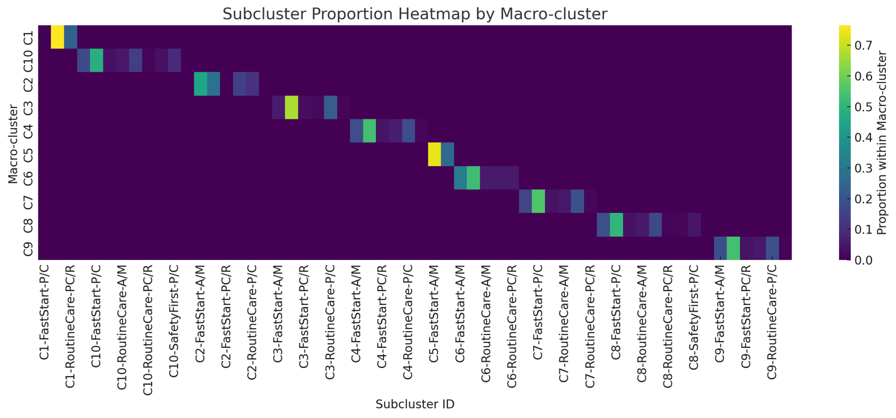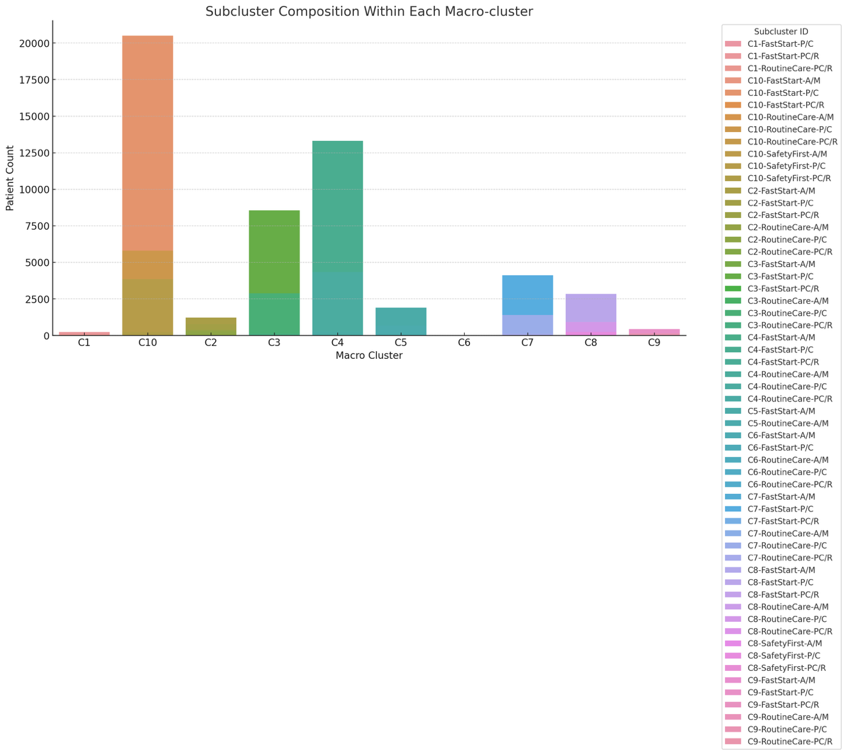
- C1: 328
- C2: 2,705
- C3: 12,838
- C4: 24,815
- C5: 2,563
- C6: 19
- C7: 7,431
- C8: 5,672
- C9: 848
- C10: 42,781

Cluster | Label / Theme | Core Traits | Representative Profile
C1 | Disengaged / Low Insight | Low motivation, low risk perception, minimal portal engagement, often poor adherence | Unmotivated, low literacy, infrequent follow-up
C2 | Dependent / Caregiver-driven | Has caregiver involvement, low digital engagement, replies inconsistently | Elderly or frail with caregiver support
C3 | Anxious / Risk-sensitive | High risk perception, rapid response times, moderate literacy | Highly concerned, tends to overestimate risk
C4 | Researcher / Engaged Portal User | Portal-active, good literacy, consistent engagement | Proactive, self-managing, uses digital tools
C5 | Compliant / High-performing | High open/reply rates, low latency, excellent adherence | Model patient, strong motivation and follow-through
C6 | Stoic / Non-expressive | Opens messages but rarely replies, moderate adherence | Silent but cooperative, prefers autonomy
C7 | Reactant / Autonomous Resister | High autonomy, low reply rate, resists perceived control | Independent, Type A, low tolerance for nudging
C8 | Low Literacy / Simplifier | Low health literacy, limited comprehension, minimal engagement | Needs plain-language and caregiver support
C9 | Digital Native / Tech-comfortable | High digital comfort, high open rate, portal-active | Younger or tech-savvy patient using apps
C10 | Safety-first / Medically Complex | CKD, warfarin, high HAS-BLED, unstable INR | Clinically fragile, high supervision need

